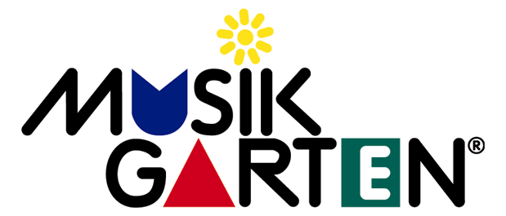
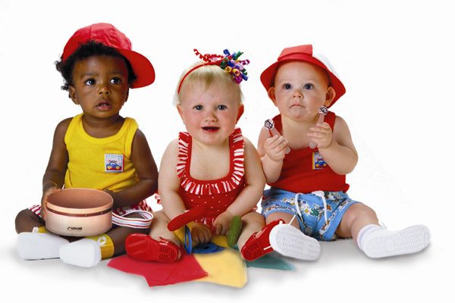
First Attend Musikgarten, then take-up Piano or Violin Lessons
A Registered Trademark of MUSIKGARTEN USA

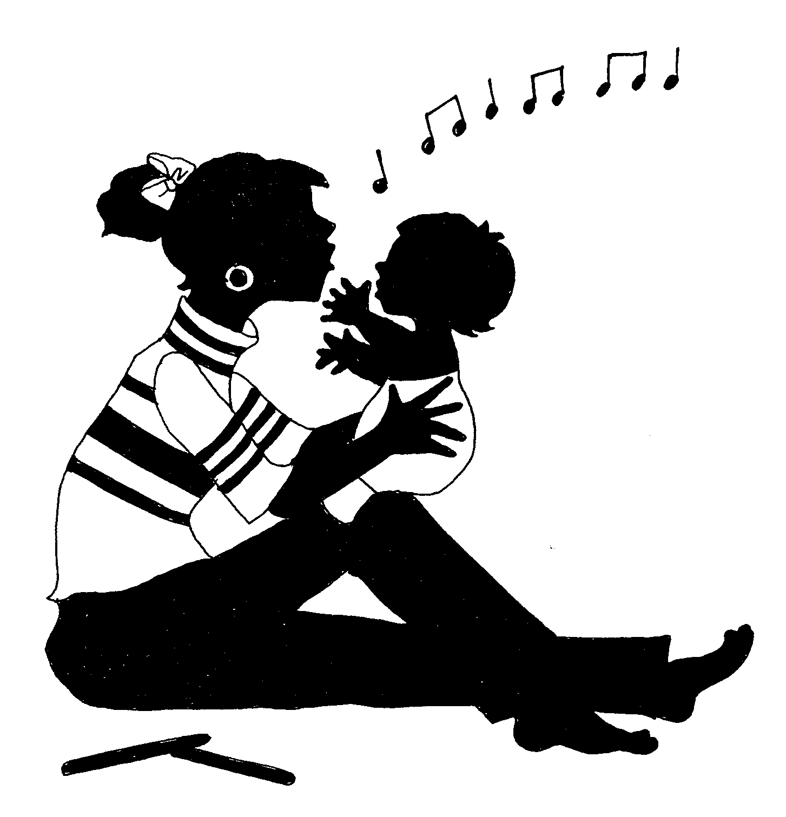

Family Music for Babies
(For Parents with Babies from Birth to 16 months old)
Class Duration: 30 mins. Once a week.
Family Packs (Compulsory): Parent Books & CDs

- Group Class for parents to attend with their babies;
- Parents will learn how to bond and play musically with their babies
- Activities include learning how to sing, move, dance, rock, bounce their babies and play wiggle, tickle and peek-a-boo games;
- Parents will learn activities that help in the left and right brain development of the child;
- This programme is also suitable for pregnant mothers - the foetus will be bathed in the musical environment which promotes brain development. Parents will learn how to bond and play musically with the new born baby.

