
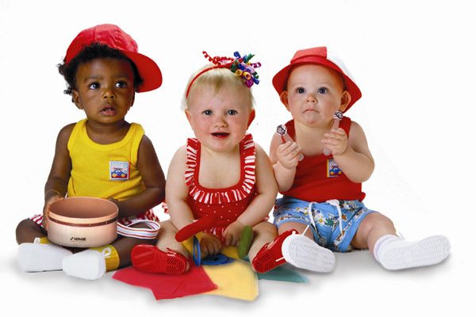
First Attend Musikgarten, then take-up Piano or Violin Lessons
A Registered Trademark of MUSIKGARTEN USA

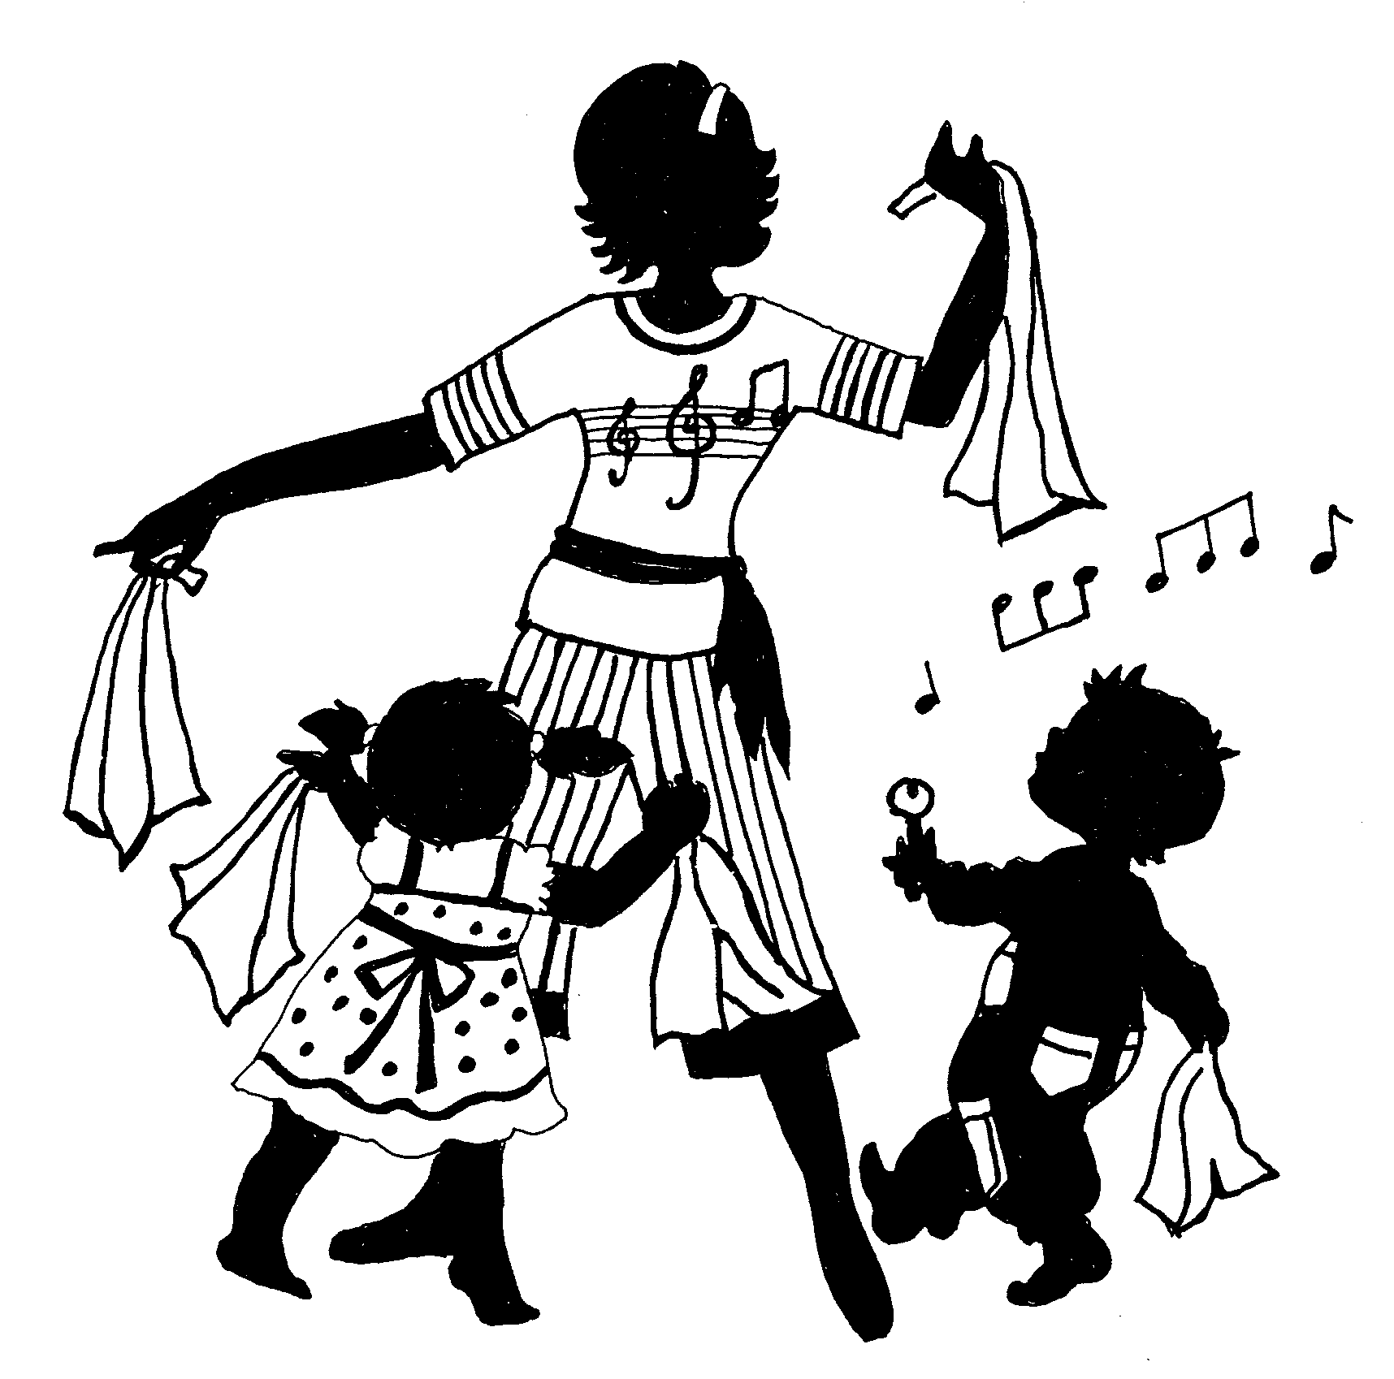

Cycles of Seasons
(For Children 4 - 5 ½ years old)
Class Duration: 45 mins. Once a week.
Family Packs (Compulsory): Parent Books & CDs

- Group Class for children to attend independently. Parents are invited to participate in the class during the last 15 minutes (Parent Sharing Time);
- Children will experience activities that promote Language, Socio-emotional , Physical, Creative & Musical Development;
- Children will be introduced to sequential learning of musical concepts necessary for a strong musical foundation, all done in a fun and stress-free environment;
- Children will learn music like a language through Rhythm Patterns (Gordon Rhythm Language) and Tonal Patterns (SOLFEGE, Music and Songs in Major & Minor Keys).
- Activities include singing, chanting, moving, dancing, listening, playing musical instruments, story-telling, dramatisation, and interpretation of different kinds music.

