
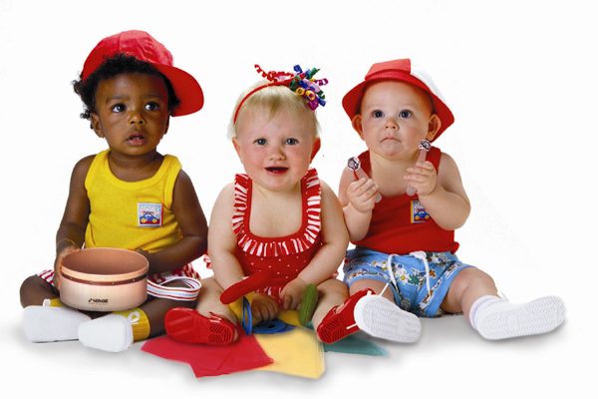
First Attend Musikgarten, then take-up Piano or Violin Lessons
A Registered Trademark of MUSIKGARTEN USA

Music Makers At the Keyboard
(For Children 5 ½ Years & Above)
Class Duration: 60 mins. Once a week
Children’s Packs (Compulsory): Books & CDs

- A Comprehensive Musicianship programme for Children;
- Group Class for Children to attend independently. Parents are invited to participate in the class during the last 15 minutes (Parent Education and Sharing Time);
- Children will experience activities that leads to “Musical Literacy i.e. ability to play by ear and by reading notes”;
- Children will learn musical concepts progressively in a structured sequential way, through games, movement, drumming, singing, dancing and listening activities, all done in a fun and stress-free environment;
- Children will be guided on proper sitting posture, hand & finger positions at the keyboard. They will learn how to play music pieces with two hands together on the keyboard.

